Name: ___________________________

Skateboard Flex
  - Goal: Students will learn how “flex” can be measure through this skateboard activity.
Objectives:
- The students will describe a real world situation in terms of ratios.
- The student will perform operations with decimal numbers.
- The student will discover the mean of a set of data.
- The student will plot a point in a two-dimensional coordinate system, given the coordinates.
- The student will relate aspects of a graphical model to the real world situation which is being modeled.
  - Materials:
- Two different rulers (wooden, plastic, rubber) with a hole in the center (per group)
- One ruler with millimeter markings (per group)
- One heavy duty paper clip (per group)
- A plastic cup ( the type with a rolled rim) with a hole punch just underneath the rim(per group)
- 200 pennies (per group)
- Two stacks of textbooks each at least one foot high
- Graph paper
- Pencil
  - Procedure:
- Get three different rulers (wooden, thicker plastic, thinner plastic, or rubber). One should have millimeters measurement.

- Lay one ruler across the two stacks of books at least one foot high. There should be exactly 1 inch of each end of the ruler on the books.

- Measure the height of the ruler before hooking the cup on the ruler. That way you can know how much the ruler flexed once you add pennies.

- Take the plastic cup with the small hole punch and put one end of a paper clip through the hole. Hook the other end of the paperclip through the center hole in the ruler, so that the cup is hanging between the stacks of books.

- Add 25 pennies to the cup, and measure using the milliliter ruler how far the center of the ruler is bent. Record in the data table the measurement. Then add another 25 pennies, and measure again.

- Make at least three or more measurements with different amounts of pennies. And record your data in the table below.

- For each measurement you made, divide the amount of ruler flex by the number of pennies in order to find the ratio of “flex per penny,” as a decimal. Record the “flex per penny” in the data table.

First Ruler Flex
# of Pennies | Ruler flex  (in millimeters) | Ratio of “flex per penny”  (as a decimal)
1.)
2.)
3.)
4.)
5.)

- Find the mean of these ratios for all measurements.

___________________________________

- Repeat the measurements with another ruler, one different from the first (for example, a wooden ruler, or a thicker plastic ruler).

- Record each trial and measurement for the second ruler in the data box below.

- Find the ratio of “flex per penny,” as a decimal for each measurement. Record in the data table below.

Second Ruler Flex
# of Pennies | Ruler flex  (in millimeters) | Ratio of “flex per penny”  (as a decimal)
1.)
2.)
3.)
4.)
5.)

- The mean of these ratios for all measurements.
________________________________

- On the space provided below, independently write your conclusions. Describe your results. Did you see a pattern in your ruler flex results? Explain what the ratio of “flex per penny” tells you about the two rulers.

  - Observation & Conclusions:
________________________________________________________________________
______________________________________________________________________________
______________________________________________________________________________
______________________________________________________________________________
______________________________________________________________________________
______________________________________________________________________________
______________________________________________________________________________
______________________________________________________________________________
______________________________________________________________________________
______________________________________________________________________________

  - Optional Extension:
  - Ask students, working in groups, to graph the ordered pairs of data that they have collected (number of pennies, flex), for each of the two rulers tested, on the same sheet of graph paper, and to explain what the graphs show.
  - Have them discuss:
- Whether the amount of flex seems to depend on the number of pennies
- How that dependence could be described
- In what ways that dependence is different for the two rulers tested.

Citation: http://www.thefutureschannel.com/hands-on_math/skateboard_flex.php

Skateboard Flex
  - One important quality of a skateboard is its “flex”—how far the deck will bend when weight is put on it, and how well it snaps back to its original shape.
  - The deck in this diagram has some flex:
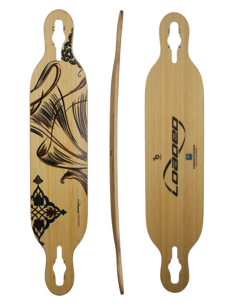

  - This deck doesn’t have as much flex:
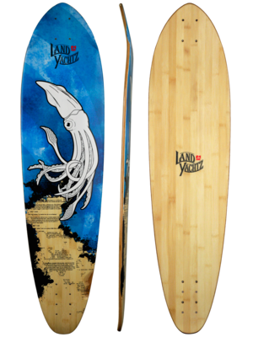

  - The amount of flex that something has depends on what it is made of, and how it is made. Skateboard designers make their decks out of several thin layers of wood in order to give them the right amount of flex.

